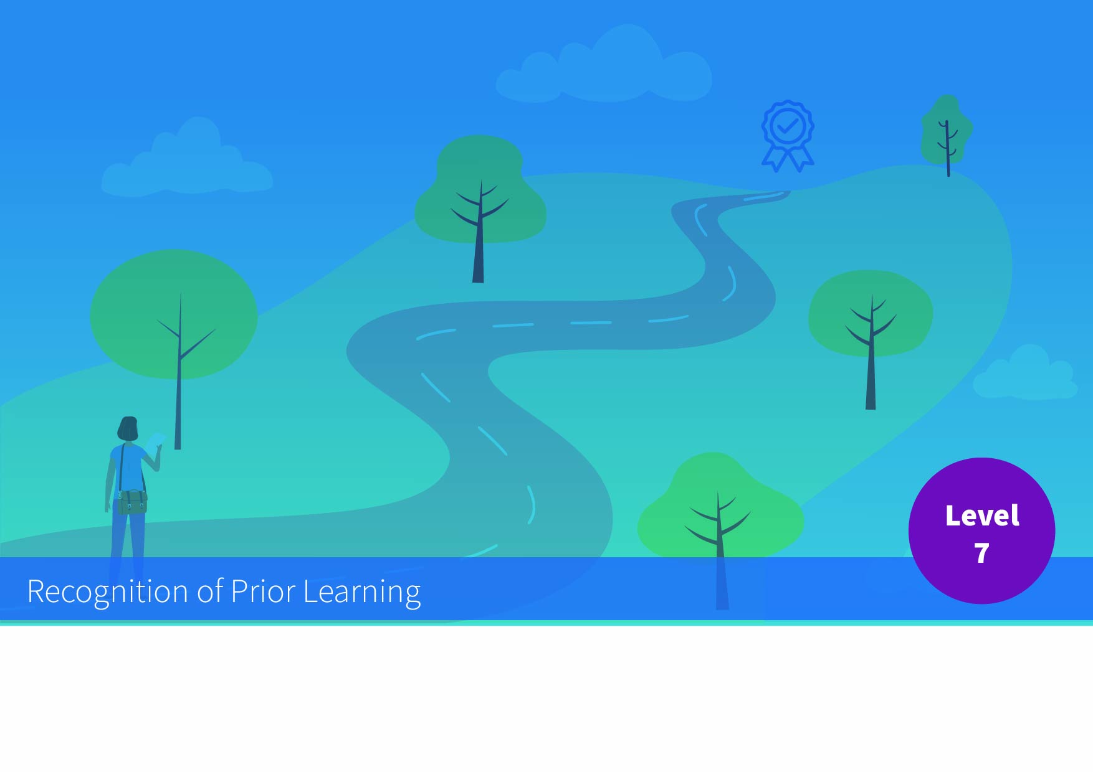


Rubric for Generic Award Standard NFQ Level 7

Applicant and Process Details
Applicant
Programme
Date
Assessment Details | i.e. Course Committee met on X

QQI NFQ Level 7 Award Standard
(Awards Standards - Generic Higher Education and Training, QQI July 2014/HS4)
Award Title | Ordinary Bachelor Degree (Generic)
Purpose | This is a multi-purpose award-type. The knowledge, skill and competence acquired are relevant to personal development, participation in society and community, employment, and access to additional education and training.
Level | 7 (Major Award)
Volume | ECTS (3x 60 ECTS minimum for Ordinary Bachelor Degree)

RPL Evidence Evaluation against Level 7 Standard
It would be expected that a generic Award at NFQ Level 7, equivalent to an Ordinary Bachelor Degree, would be associated with the following graduate attributes across the categories of Knowledge, Skill and Competence.
Criteria Strand | Description | RPL Evidence Evaluation (Comment)
Knowledge – breadth | Specialised knowledge across variety of areas.
Knowledge – Kind | Recognition of limitations of current knowledge and familiarity with sources of new knowledge; integration of concepts across a variety of areas.
Know-how and skill-range | Demonstrate specialised technical, creative or conceptual skills and tools across an area of study.
Know-how and skill-selectivity | Exercise appropriate judgement in planning, design, technical and/or supervisory functions related to products, services, operations or processes.
Competence – context | Utilise diagnostic and creative skills in a range of functions in a wide variety of contexts.
Competence – role | Accept accountability for determining and achieving personal and/or group outcomes; take significant or supervisory responsibility for the work of others in defined areas of work
Competence – learning to learn | Take initiative to identify and address learning needs and interact effectively in a learning group
Competence – insight | Express an internalised, personal world view, manifesting solidarity with others

