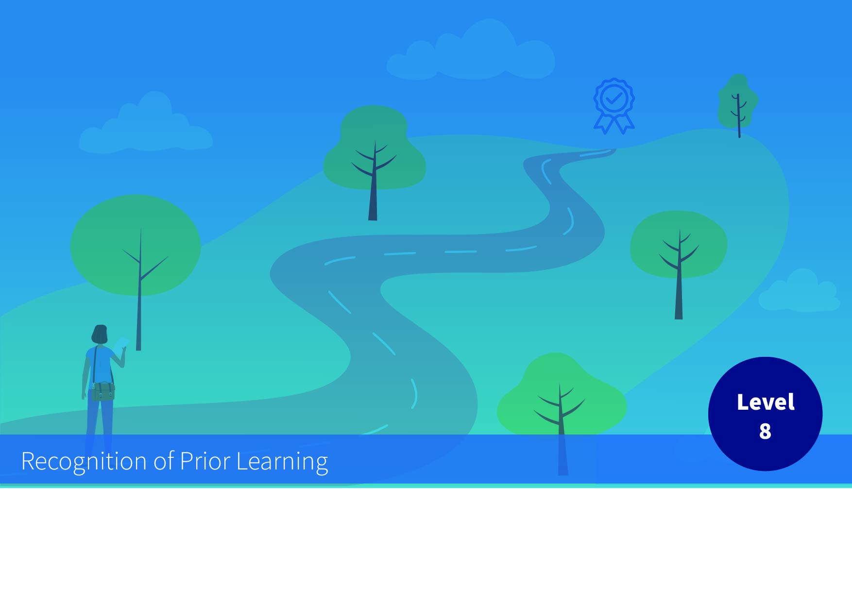


Rubric for Generic Award Standard NFQ Level 8

Applicant and Process Details
Applicant
Programme
Date
Assessment Details | i.e. Course Committee met on X

QQI NFQ Level 8 Award Standard
(Awards Standards - Generic Higher Education and Training, QQI July 2014/HS4)
Award Title | Honours Bachelor Degree (Generic)
Purpose | This is a multi-purpose award-type. The knowledge, skill and competence acquired are relevant to personal development, participation in society and community, employment, and access to additional education and training.
Level | 8 (Major Award)
Volume | ECTS (3x 60 ECTS minimum for Ordinary Bachelor Degree (Arts), all others 4x 60 ECTS)

RPL Evidence Evaluation against Level 8 Standard
It would be expected that a generic Award at NFQ Level 8, equivalent to an Ordinary Bachelor Degree, would be associated with the following graduate attributes across the categories of Knowledge, Skill and Competence.
Criteria Strand | Description | RPL Evidence Evaluation (Comment)
Knowledge – breadth | An understanding of the theory, concepts and methods pertaining to a field (or fields) of learning
Knowledge – kind | Detailed knowledge and understanding in one or more specialised areas, some of it at the current boundaries of the field(s)
Know-how and skill-range | Demonstrate mastery of a complex and specialised area of skills and tools; use and modify advanced skills and tools to conduct closely guided research, professional or advanced technical activity
Know-how and skill-selectivity | Exercise appropriate judgement in a number of complex planning, design, technical and/ or management functions related to products, services, operations or processes, including resourcing
Competence – context | Use advanced skills to conduct research, or advanced technical or professional activity, accepting accountability for all related decision making; transfer and apply diagnostic and creative skills in a range of contexts
Competence – role | Act effectively under guidance in a peer relationship with qualified practitioners; lead multiple, complex and heterogeneous groups
Competence – learning to learn | Learn to act in variable and unfamiliar learning contexts; learn to manage learning tasks independently, professionally and ethically
Competence – insight | Express a comprehensive, internalised, personal world view manifesting solidarity with others

