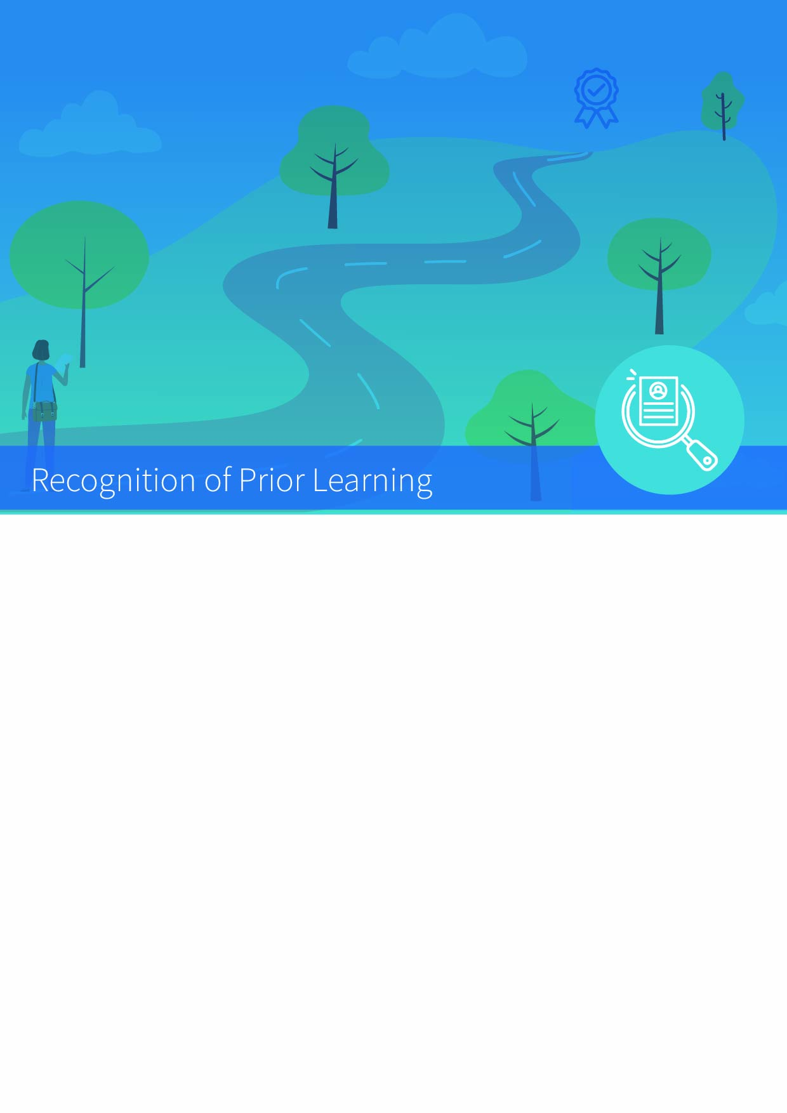


RPL Applicant Evidence Form

RPL Applicant Evidence Form

Based on the portfolio of prior learning experience you may have already submitted, you may be invited to complete an RPL Applicant Evidence form. If required to complete this form, you will be asked to outline prior academic (formal learning) or experiential evidence (non-formal and informal learning) of knowledge, skills, and competence that may be relevant or related to the specific course or programme you are applying for.

The table below is a guide to the information you may need to provide regarding the general criteria of Knowledge and Competence. As an applicant, try to address the criteria as comprehensively as possible with reference to your formal, non-formal and informal learning experiences. Try to be specific and succinct, and include dates/times/locations of achievement as applicable.

Criteria | Description | RPL Evidence
Knowledge – breadth | An understanding of the theory, concepts and methods pertaining to a field (or fields) of learning
Knowledge – kind | Detailed knowledge and understanding in one or more specialised areas, some of it at the current boundaries of the field(s)
Know-how and skill-range | Demonstrate mastery of a complex and specialised area of skills and tools; use and modify advanced skills and tools to conduct closely guided research, professional or advanced technical activity
Know-how and skill-selectivity | Exercise appropriate judgement in a number of complex planning, design, technical and/ or management functions related to products, services, operations or processes, including resourcing
Competence – context | Use advanced skills to conduct research, or advanced technical or professional activity, accepting accountability for all related decision making; transfer and apply diagnostic and creative skills in a range of contexts
Competence – role | Act effectively under guidance in a peer relationship with qualified practitioners; lead multiple, complex and heterogeneous groups
Competence – learning to learn | Learn to act in variable and unfamiliar learning contexts; learn to manage learning tasks independently, professionally and ethically
Competence – insight | Express a comprehensive, internalised, personal world view manifesting solidarity with others

