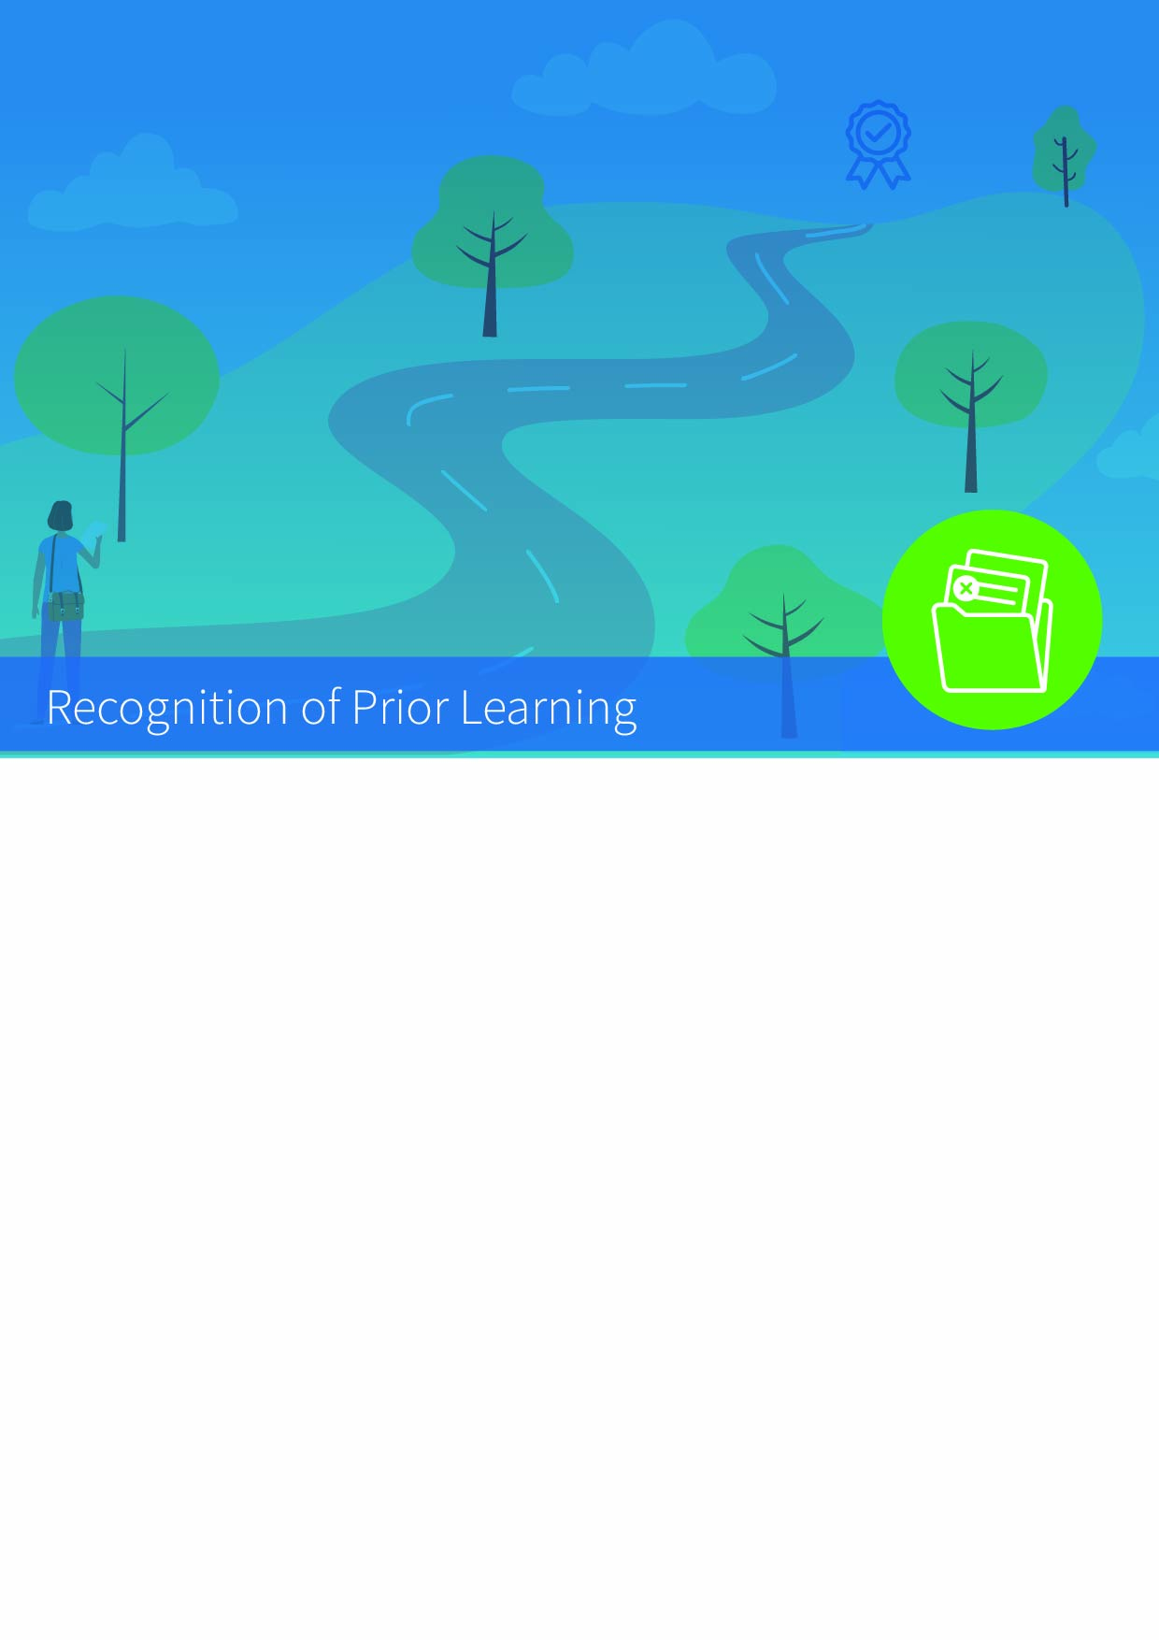


RPL Case Application for Module Exemption

Part A: RPL Case Details
School
School Case Reviewers
RPL Case Assistant
Applicant
Target Programme
Target Stage (Year/Semester)
Target NFQ Level (L8/L9)
Number of Exemption requests
RPL Evidence Presented
Case Submission Date

Part B: Learning Outcome Mapping
Target Module | Module Title / Code / Stage
Total ECTS (Credits)
Learning Outcome 1 | (Copy explicit learning outcome here)
Learning Outcome 1 | Applicant Evidence | (formal, non-formal, informal)
Learning Outcome 2 | (Copy explicit learning outcome here)
Learning Outcome 2 | Applicant Evidence | (formal, non-formal, informal)
Learning Outcome 3 | (Copy explicit learning outcome here)
Learning Outcome 3 | Applicant Evidence | (formal, non-formal, informal)
Learning Outcome 4 | (Copy explicit learning outcome here)
Learning Outcome 4 | Applicant Evidence | (formal, non-formal, informal)
Learning Outcome 5 | (Copy explicit learning outcome here)
Learning Outcome 5 | Applicant Evidence | (formal, non-formal, informal)
(Repeat as necessary)
School Comments | (Why you believe the mapping from source to target module learning has been successfully achieved)
School Recommendation | (The recommendation can be simply to provide the exemption, it may also include a requirement for the applicant to engage in non-formal learning)

Part C: Specific Assignment / Task Provided to Applicant (if applicable)

