
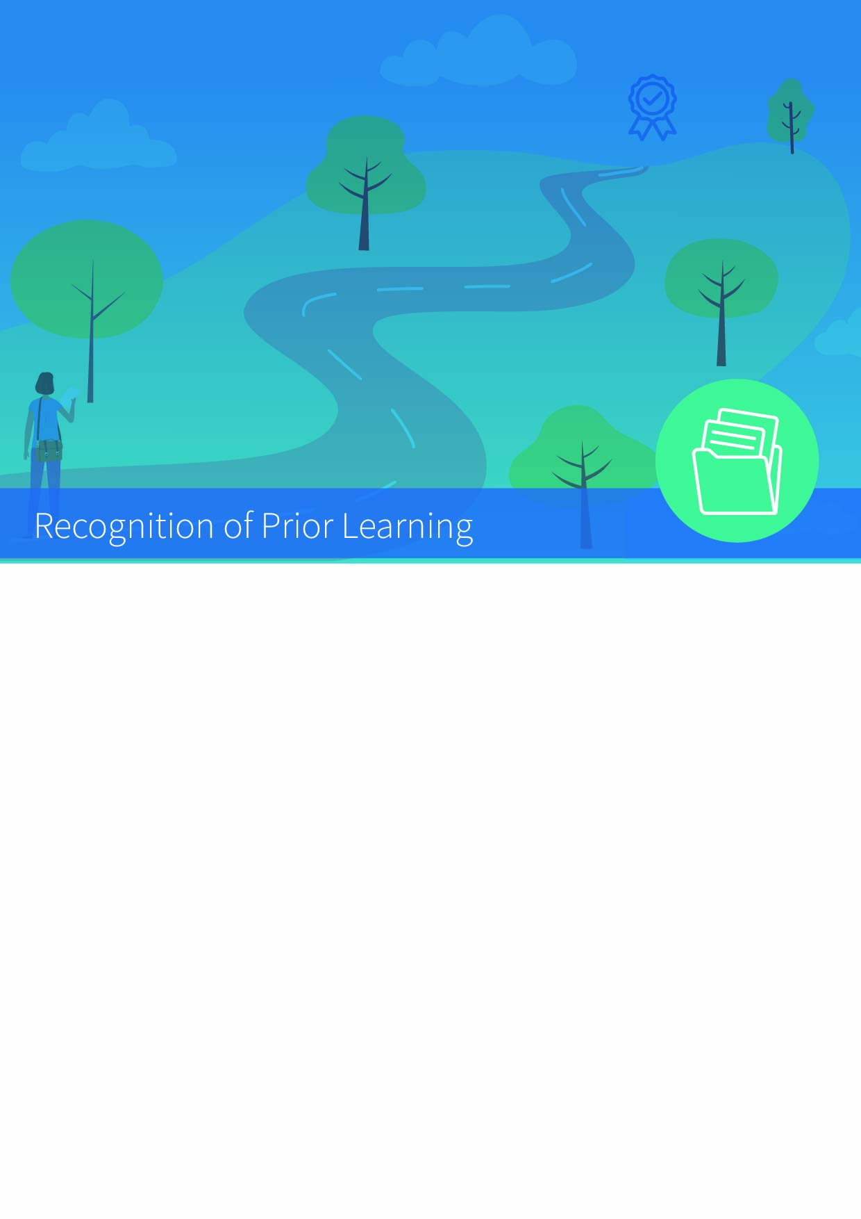

RPL Case Application for Programme Entry or Advanced Entry

Part A: RPL Case Details
School
School Case Reviewers
RPL Case Assistant
Applicant
Target Programme
Entry Requirements
RPL for Entry/Advanced Entry
RPL Evidence Presented
Case Submission Date:

Part B: RPL Evidence Review
Formal Learning | Certificates:  Diploma:
Non-Formal Learning | Continuing Professional Development, Self-directed Learning etc.
Informal Learning | Role | Dates
Informal Learning | - Job Title and Work Learning Experience
Informal Learning | - Job Title and Work Learning Experience
Informal Learning | - Etc.
Achievements
Case Rationale
School Comments
School Recommendation

Part C: Specific Assignment / Task Provided to Applicant (if applicable)

